**EXPERIMENT 7**

**DQL COMMANDS (COLLEGE SCHEMA)**

**Aim:**

* Display student id and marks from the student table.
* Display faculty id and name from the faculty table.
* Display who got grade A.
* Display whose marks are less than 50.
* Display the female students whose marks are between 50 to 60.
* Delete the failed students.
* Display activity id and name using object.
* Display student id, faculty id using course name condition with object.
* Select department name starting from ‘c’ and faculty name ending with ‘ ’.
* Select activity having characters between ‘ck’.
* Group by faculty id and display.
* Display the students list whose grade is A using having.
* Display the faculty list who are teaching PPS.
* Apply aggregate functions in student marks - max, min, sum, count, avg.

**Code:**

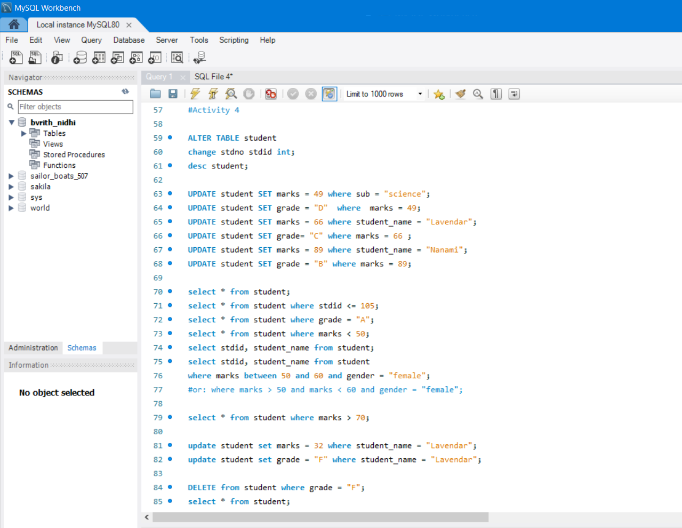

**Output:**

Student table after renaming row 1st 5 students

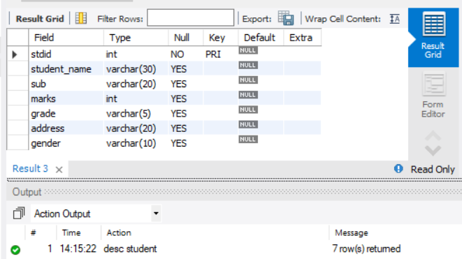 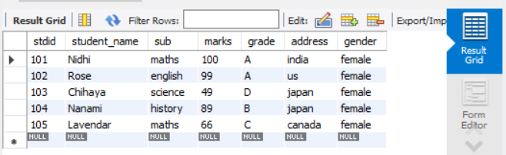

Students who got grade A Students with marks less than 50

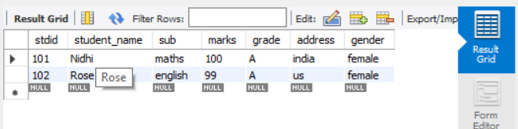 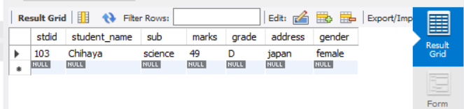

Stdid, stdname Female students with marks between 50 and 60 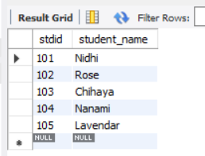 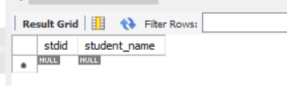

Students with marks > 70 After deleting failure students

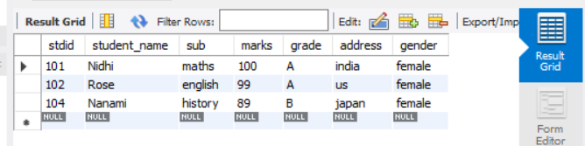 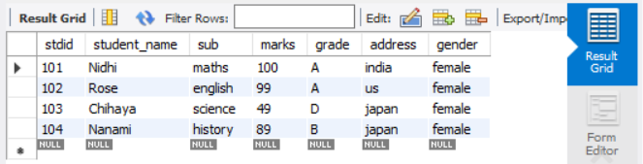

**Code:**

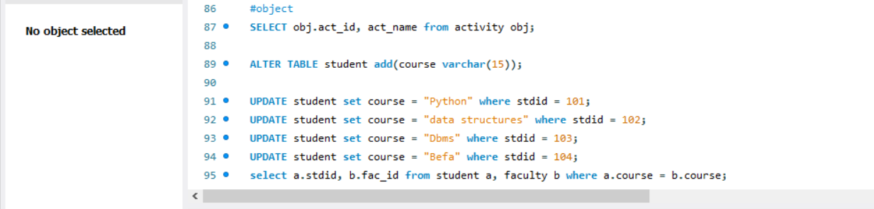

**Output:**

Act_id, act_name using object stdid, fac_id when same course using objects

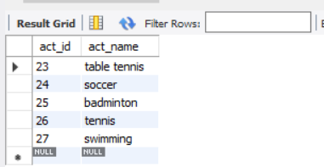 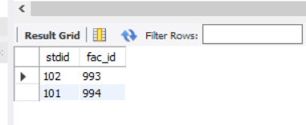

**Code:**

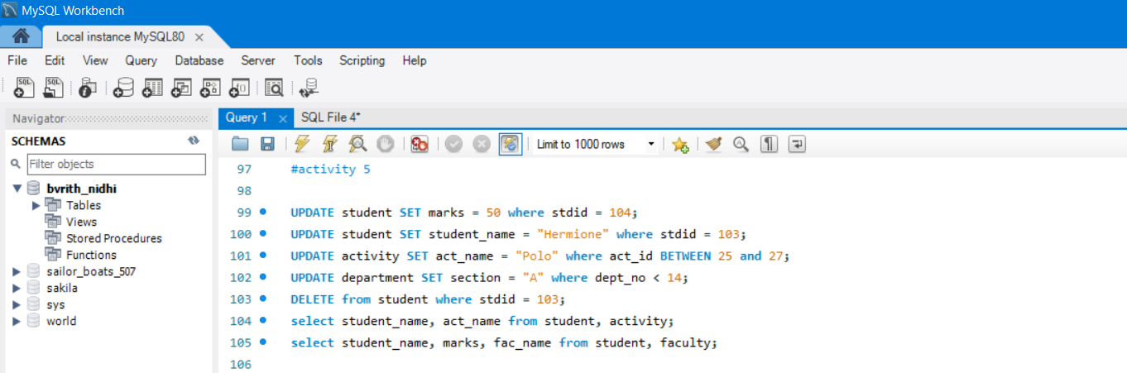

**Output:**

Student_name, act_name student_name, marks, fac_name

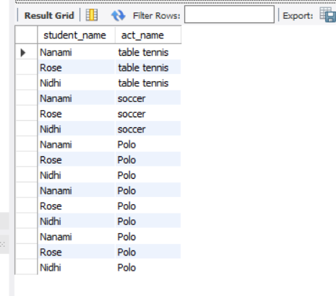 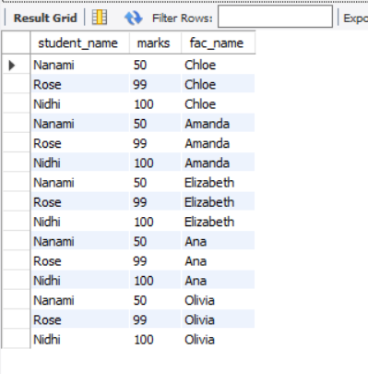

**Code:**

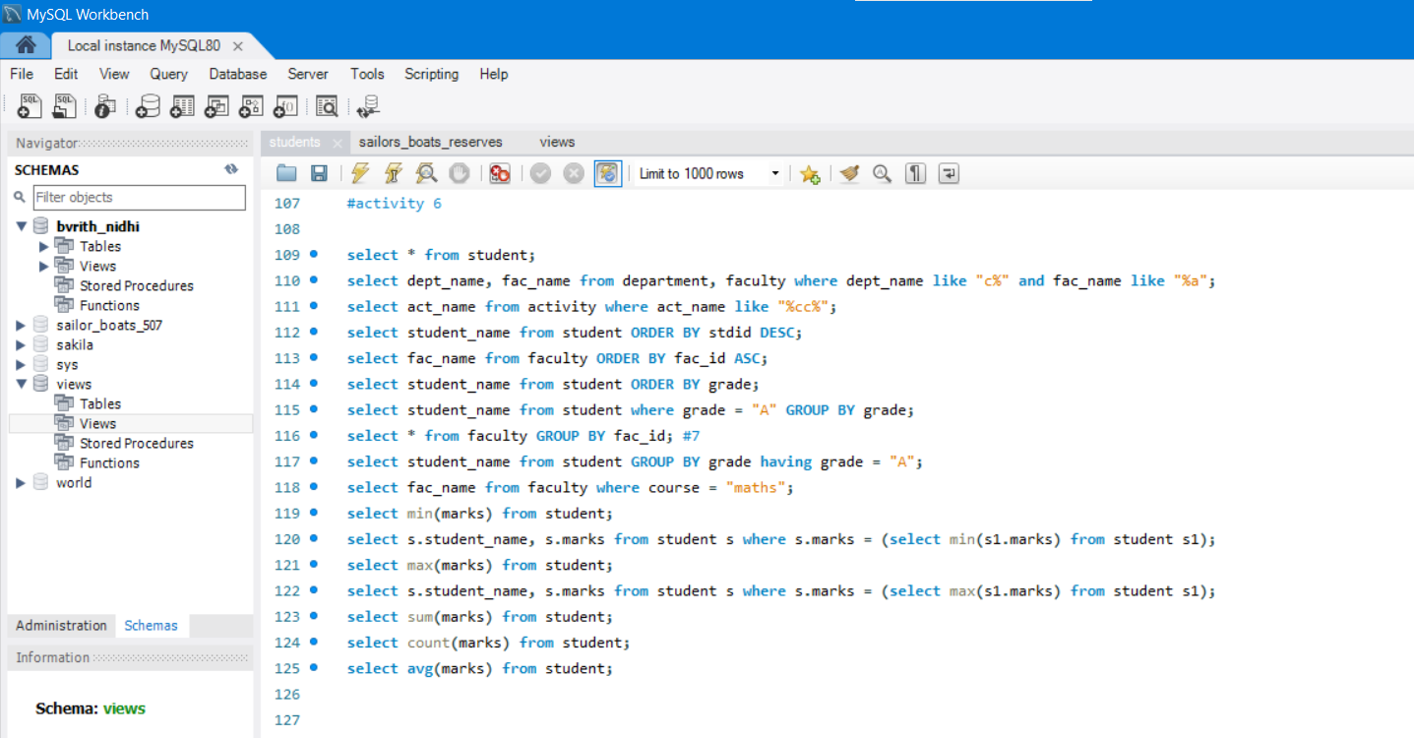

**Output:**

1. Dept_name starting from c, 2. Act_name having cc 3. Student name wrt stdid in

fac_name ending with a desc order

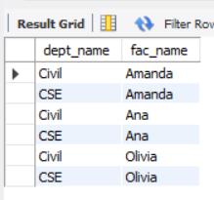 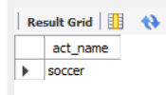 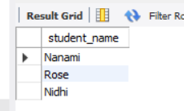

4. fac_name wrt fac_id in 5. Student names wrt grade 6. Students having grade A with

asc order group by

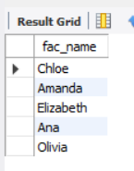 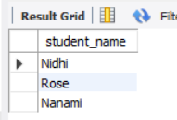 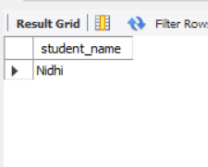

7. Group by faculty id

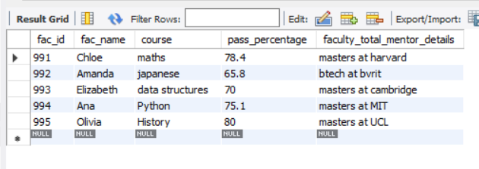

8. Students list of grade A 9. Faculty list who teaches maths

using having

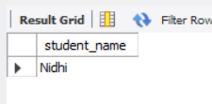 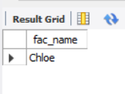

10.(i) min marks (ii) min marks with name (iii) max marks (iv) max marks with name

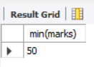 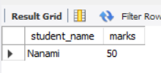 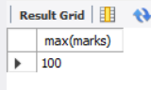 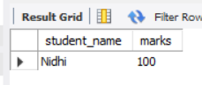

(v) sum of marks (vi) count of marks (vii) average of marks

